OUTREACH MATERIALS FOR CLIMATE DAY PARTNERS

Last updated 1/30/17

Thank you so much for your support of Climate Day! Below is a selection of outreach materials you can use to help spread the word about the event on March 8th at Expo West. Feel free to modify these materials to best suit your needs and don’t hesitate to contact us if you need anything else – just email Lara Dickinson at lara@osc2.org or Nancy Hirshberg at nancy@nhirshberg.com.
SHORTER
Option 1: For Groups Attending Climate Day
Concerned about climate change but not sure what your company can do? Join us at the first-ever Climate Day on Wednesday, March 8th at Expo West to get the tools, information and inspiration you need to help your company take meaningful action to reverse climate change.
Join <your group> and UNFI, National Co+op Grocers, INFRA, Annie’s, Stonyfield, Guayaki, White Wave, Dr. Bronner’s, REBBL, LOTUS, Happy Family, Nature’s Path, Patagonia and many more for inspirational talks, executive roundtables, workshops, music, networking, climate awards, a rockin’ reception with food and beer and a film screening of Kiss The Ground, a beautiful film on the potential of soils and farming to address the climate crisis.
Leading environmentalist and author, Paul Hawken will give the keynote address on his inspirational work with Project Drawdown. Working with more than 200 scientists around the world, Project Drawdown has identified 100 solutions which when deployed at scale can slow and eventually, reverse climate change.
Climate Day is co-hosted by New Hope and the Climate Collaborative. We so hope you will join us to share new ideas, learn proven solutions, make connections and spread HOPE. All Climate Day events are free with your Expo West exhibit hall pass. Learn more and register to join us here.
Option 2: For Groups Attending Climate Day
Climate change is the greatest threat our planet has ever faced but it’s also the greatest opportunity we’ve ever had to make positive change through innovation and leadership.
The natural products industry has successfully led the charge on animal welfare, organic farming, fair trade practices, and non-GMOs. Now, we’re gearing up to take the lead on climate change and we plan to go way beyond just calculating your carbon footprint!
That’s why <your group> will be attending the first-ever Climate Day on Wednesday, March 8th at Expo West – a jam-packed day of inspirational talks from industry visionaries and climate experts, a retailer and an executive roundtable, great music, the National Co+op Grocers Climate Awards, films, a reception where you can meet and mingle, and more.
Leading environmentalist and author, Paul Hawken will give the keynote address on his inspirational work with Project Drawdown. Working with more than 200 scientists around the world, Project Drawdown has identified 100 solutions which when deployed at scale can slow and eventually, reverse climate change.
Climate Day is co-hosted by New Hope and the Climate Collaborative. We hope you will join us to share new ideas, learn proven solutions, make connections and spread HOPE. All Climate Day events are free with your Expo West exhibit hall pass. Learn more and register to join us here.
-------------------------------------------------------------------------------------------------
Option 3: For Groups NOT Attending Climate Day
Concerned about climate change but not sure what your company can do? Come to the first-ever Climate Day on Wednesday, March 8th at Expo West in Anaheim, CA to get the tools, information and inspiration you need to help your company take meaningful action to reverse climate change.
Join industry leaders from UNFI, National Co+op Grocers, INFRA, Annie’s, Stonyfield, Guayaki, White Wave, Dr. Bronner’s, REBBL, LOTUS, Happy Family, Nature’s Path, Patagonia and many more for inspirational keynotes, executive roundtables, workshops, music, networking, climate awards, a rockin’ reception with food and beer and a film screening of Kiss The Ground, a beautiful film on the potential of soils and farming to address the climate crisis.
Leading environmentalist and author, Paul Hawken will give the keynote address on his inspirational work with Project Drawdown. Working with more than 200 scientists around the world, Project Drawdown has identified 100 solutions which when deployed at scale can slow and eventually, reverse climate change.
Climate Day is co-hosted by New Hope and the Climate Collaborative and is a wonderful opportunity to share new ideas, learn proven solutions, make connections and spread HOPE. All Climate Day events are free with your Expo West exhibit hall pass. Learn more and register here.
Option 4: For Groups NOT Attending Climate Day
Climate change is the greatest threat our planet has ever faced but it’s also the greatest opportunity we’ve ever had to make positive change through innovation and leadership.
The natural products industry has successfully led the charge on animal welfare, organic farming, fair trade practices, and non-GMOs. Now, we’re gearing up to take the lead on climate change!
If you want to be part of the solution, come to the first-ever Climate Day on March 8th at Expo West in Anaheim, CA. It’s going to be a jam-packed day of inspirational talks from top visionaries and experts, a retailer and an executive roundtable, great music, the National Co+op Grocers Climate Awards, films, a reception where you can meet and mingle, and more.
Leading environmentalist and author, Paul Hawken will give the keynote address on his inspirational work with Project Drawdown. Working with more than 200 scientists around the world, Project Drawdown has identified 100 solutions which when deployed at scale can slow and eventually, reverse climate change.
This inaugural event is co-hosted by New Hope and the Climate Collaborative and is a wonderful opportunity to share new ideas, learn proven solutions, make connections and spread HOPE. All Climate Day events are free with your Expo West exhibit hall pass. Learn more and register here.
-------------------------------------------------------------------------------------------------
LONGER
Option 1: For Groups Attending Climate Day
Concerned about climate change but not sure what your company can do? Join us in kicking off the first-ever Climate Day at Expo West on Wednesday, March 8th to get the tools, information and inspiration you need to help your company take meaningful action to reverse climate change.
The natural products industry has a proud history of successfully leading the way on issues like animal welfare, organic agriculture, fair trade practices, and GMOs. Now it’s time to lead on climate!
That’s why <your group> is heading to the first-ever Climate Day on Wednesday, March 8th at Expo West to share new ideas, learn about proven solutions, make connections and spread hope.
Join us and UNFI, National Co+op Grocers, INFRA, Annie’s, Stonyfield, Guayaki, White Wave, Dr. Bronner’s, REBBL, LOTUS, Happy Family, Nature’s Path, Patagonia and many more for inspirational talks, executive roundtables, workshops, music, networking, climate awards, a rockin’ reception with food and beer, and a film screening of Kiss The Ground, a beautiful film on the potential of soils and farming to address the climate crisis.
Leading environmentalist and author, Paul Hawken will give the keynote address on his inspirational work with Project Drawdown. Working with more than 200 scientists around the world, Project Drawdown has identified 100 solutions which when deployed at scale can slow and eventually, reverse climate change.
Not only is taking bold action on climate the right thing to do for our planet, it’s also a smart business decision. Growing consumer concern about climate change –especially among millennials- can translate into a great opportunity for your company and our entire industry. And taking the lead on climate-friendly business practices can also help make your company more attractive to potential investors who are increasingly focused on climate.
Climate Day is co-hosted by New Hope and the Climate Collaborative, a project of OSC2 and SFTA, and is a wonderful opportunity to share new ideas, learn proven solutions, make connections, and spread HOPE.
Please join us to get our industry in gear to reverse climate change. All Climate Day events are free with your exhibit hall pass. Learn more and register here.
Option 2: For Groups Attending Climate Day
Climate change is the greatest threat our planet has ever faced but it’s also the greatest opportunity we’ve ever had to make positive change through innovation and leadership.
The natural products industry has a proud history of successfully leading the way on issues like animal welfare, organic agriculture, fair trade practices, and GMOs. Now it’s time to lead on climate!
That’s why <your group> is heading to the first-ever Climate Day on Wednesday, March 8th at Expo West to share new ideas, learn about proven solutions, make connections and spread hope.
It’s going to be a jam-packed day of inspirational talks from industry visionaries and climate experts, an executive and a retailer roundtable, great music, the National Co+op Grocers Climate Awards, films, a reception where you can meet and mingle, and more. We so hope that you’ll join us in kicking off this inaugural event.
Leading environmentalist and author, Paul Hawken will give the keynote address on his inspirational work with Project Drawdown. Working with more than 200 scientists around the world, Project Drawdown has identified 100 solutions which when deployed at scale can slow and eventually, reverse climate change.
Climate Day is co-hosted by New Hope and the Climate Collaborative, a project of OSC2 and SFTA, and is a wonderful opportunity to share new ideas, learn proven solutions, make connections, and spread HOPE.
Not only is taking bold action on climate the right thing to do for our planet, it’s also a smart business decision. Growing consumer concern about climate change –especially among millennials- can translate into a great opportunity for your company and our entire industry. And taking the lead on climate-friendly business practices can also help make your company more attractive to potential investors who are increasingly focused on climate.
Join us for Climate Day at Expo West to meet industry leaders, hear expert speakers, get inspired, make connections and much more. All Climate Day events are free with your exhibit hall pass. Learn more and register here.
-------------------------------------------------------------------------------------------------
Option 3: For Groups NOT Attending Climate Day
The natural products industry has a proud history of successfully leading the way on issues like animal welfare, organic agriculture, fair trade practices, and GMOs. Now it’s time to lead on climate and our industry is gearing up to do more! And we plan to go WAY beyond just calculating our carbon footprint.
If you’d like to be part of the solution, come to the first-ever Climate Day on Wednesday, March 8th at Expo West in Anaheim, CA.
Join industry leaders from UNFI, National Co+op Grocers, INFRA, Annie’s, Stonyfield, Guayaki, White Wave, Dr. Bronner’s, REBBL, LOTUS, Happy Family, Nature’s Path, Patagonia and many more for a day of inspirational talks, executive roundtables, workshops, music, networking, climate awards, a rockin’ reception with food and beer, and a film screening of Kiss The Ground, a beautiful film on the potential of soils and farming to address the climate crisis.
Leading environmentalist and author, Paul Hawken will give the keynote address on his inspirational work with Project Drawdown. Working with more than 200 scientists around the world, Project Drawdown has identified 100 solutions which when deployed at scale can slow and eventually, reverse climate change.
Not only is taking bold action on climate the right thing to do for our planet, it’s also a smart business decision. Growing consumer concern about climate –especially among millennials-can translate into a great opportunity for your business and our entire industry. And taking the lead on climate-friendly business practices can also help make your company more attractive to potential investors who are increasingly focused on climate.
Make sure you plan to arrive at Expo West in time to participate in Climate Day. This inaugural event is co-hosted by New Hope and the Climate Collaborative, a project of OSC2 and SFTA and is the opportunity you’ve been looking for to share new ideas, learn about tested solutions, make connections and spread hope.
All Climate Day events are free with your exhibit hall pass. Learn more and register here.
-------------------------------------------------------------------------------------------------
Option 4: For Groups NOT Attending Climate Day
The natural products industry has a proud history of successfully leading the way on issues like animal welfare, organic agriculture, fair trade practices, and GMOs. Now it’s time to lead on climate and our industry is gearing up to do more! And we plan to go WAY beyond just calculating our carbon footprint.
If you’d like to be part of the solution, come to the first-ever Climate Day on Wednesday, March 8th at Expo West in Anaheim, CA. It’s going to be a jam-packed day of inspirational talks from industry visionaries and climate experts, an executive roundtable, great music, the National Co+op Grocers Climate Awards, films, a reception where you can meet and mingle, and more. Check out the schedule for more details.
Leading environmentalist and author, Paul Hawken will give the keynote address on his inspirational work with Project Drawdown. Working with more than 200 scientists around the world, Project Drawdown has identified 100 solutions which when deployed at scale can slow and eventually, reverse climate change.
Not only is taking bold action on climate the right thing to do for our planet, it’s also a smart business decision. Growing consumer concern about climate –especially among millennials-can translate into a great opportunity for your business and our entire industry. And taking the lead on climate-friendly business practices can also help make your company more attractive to potential investors who are increasingly focused on climate.
Make sure you plan to arrive at Expo West in time to participate in Climate Day. This inaugural event is co-hosted by New Hope and the Climate Collaborative, a project of OSC2 and SFTA and is the opportunity you’ve been looking for to share new ideas, learn about tested solutions, make connections and spread hope.
All Climate Day events are free with your exhibit hall pass. Learn more and register here.
-------------------------------------------------------------------------------------------------
SAMPLE FACEBOOK POSTS
We’d love it if you can like the Climate Collaborative on Facebook! Also, please feel free to tag any of the following groups in your post(s): @climatecollab @UNFInc @annieshomegrown @happyfamily @guayaki @LotusFoods @naturespath @REBBLElixirs @WhiteWaveFoods @DrBronner @SustainableFoodTrade @OSC2Network @newhope360 @stonyfield
--------------------------------------------------------------------------------------------------
Will we see you there?! Join us for the first-ever #ClimateDay on 3/8 at #ExpoWest. Hope & inspiration are waiting! Register today. https://www.facebook.com/events/208156492989843/
-------------------------------------------------------------------------------------------------
Come to the first-ever #ClimateDay at #ExpoWest on 3/8 for inspiration & concrete ideas on how your company can tackle climate change. Hope is waiting! Register today. https://www.facebook.com/events/208156492989843/
---------------------------------------------------------------------------------------------------

How can your company fight climate change? Find out at #ClimateDay at #ExpoWest on 3/8. Don’t miss the keynote by @paulhawkenauthor on @projectdrawdown – 100 concrete solutions to climate change. https://www.facebook.com/events/208156492989843/
---------------------------------------------------------------------------------------------------
@paulhawkenauthor will give the keynote at #ClimateDay on 3/8/17 at #ExpoWest. Find out 100 solutions to our climate crisis. Via @climatecollab. Register now. https://www.facebook.com/events/208156492989843/
-------------------------------------------------------------------------------------------------

What’s your company doing about climate change? Join us for the first-ever #ClimateDay at #ExpoWest on 3/8 to find out how to lead and meet growing consumer demand for meaningful corporate action on climate. https://www.facebook.com/events/208156492989843/

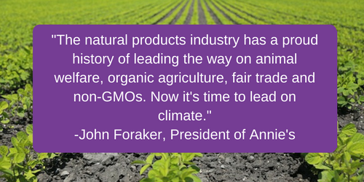

SAMPLE TWEETS

We’d love it if you follow the Climate Collaborative on Twitter! Also, feel free to tag any of the following groups in your tweets: @ClimateColl @osc2network @sustyfoodtrade @NewHope360 @NaturesPath @DrBronner @nutiva @LotusFoods @annieshomegrown @OrganicValley @Stonyfield @Guayaki @WhiteWaveFoods @HappyFamily @ProjectDrawdown @REBBLelixirs
-------------------------------------------------------------------------------------------------
Coming to @NatProdExpo ? Come hear @PaulHawken speak at #ClimateDay on 3/8 - free with your exhibit pass. Register: https://www.eventbrite.com/e/climate-day-expo-west-tickets-30825060586
-------------------------------------------------------------------------------------------------

Join us for #ClimateDay at @natprodexpo on March 8th. It's free w/ your exhibit hall pass. Register here: https://www.eventbrite.com/e/climate-day-expo-west-tickets-30825060586@newhope360
-------------------------------------------------------------------------------------------------
Coming to @natprodexpo? Join us for #ClimateDay on March 8th. Free w/ exhibit hall pass. Register: https://www.eventbrite.com/e/climate-day-expo-west-tickets-30825060586
-------------------------------------------------------------------------------------------------
Not sure what to do on climate? Come to #ClimateDay at #ExpoWest to get ideas, solutions and HOPE. Register: https://www.eventbrite.com/e/climate-day-expo-west-tickets-30825060586
-------------------------------------------------------------------------------------------------
Join us for #ClimateDay at @NatProdExpo on 3/8/17 w/ @climatecollab @newhope360 @osc2network @sustyfoodtrade Reg: https://www.eventbrite.com/e/climate-day-expo-west-tickets-30825060586
-------------------------------------------------------------------------------------------------
Growing consumer concern on climate means YOUR Co. must act! Join #ClimateDay at @natprodexpo for inspiration & more https://www.eventbrite.com/e/climate-day-expo-west-tickets-30825060586
-------------------------------------------------------------------------------------------------
Join us and @Stonyfield @HappyFamily @UNFI @Guayaki @RodaleInstitute & more at #ClimateDay at #ExpoWest on 3/8: https://www.eventbrite.com/e/climate-day-expo-west-tickets-30825060586
-------------------------------------------------------------------------------------------------
How’s your company fighting #climatechange? Get ideas & inspiration at #ClimateDay at @natprodexpo on 3/8. Register: https://www.eventbrite.com/e/climate-day-expo-west-tickets-30825060586
-------------------------------------------------------------------------------------------------

GRAPHICS
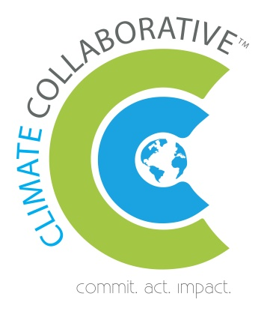

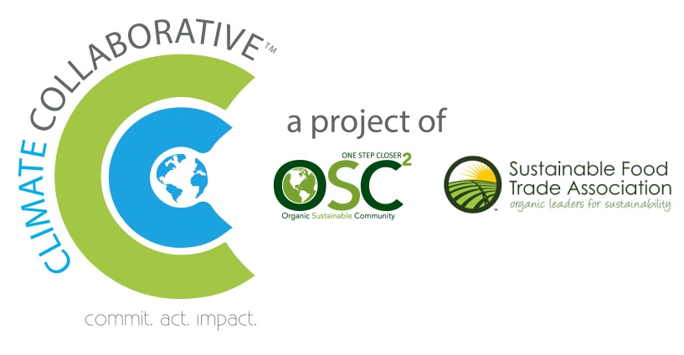

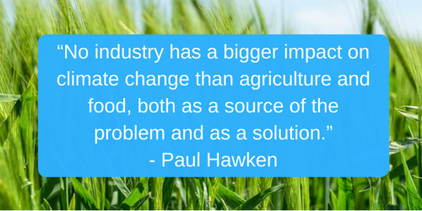
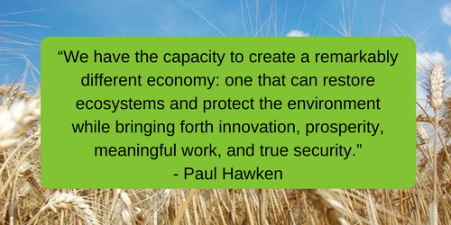

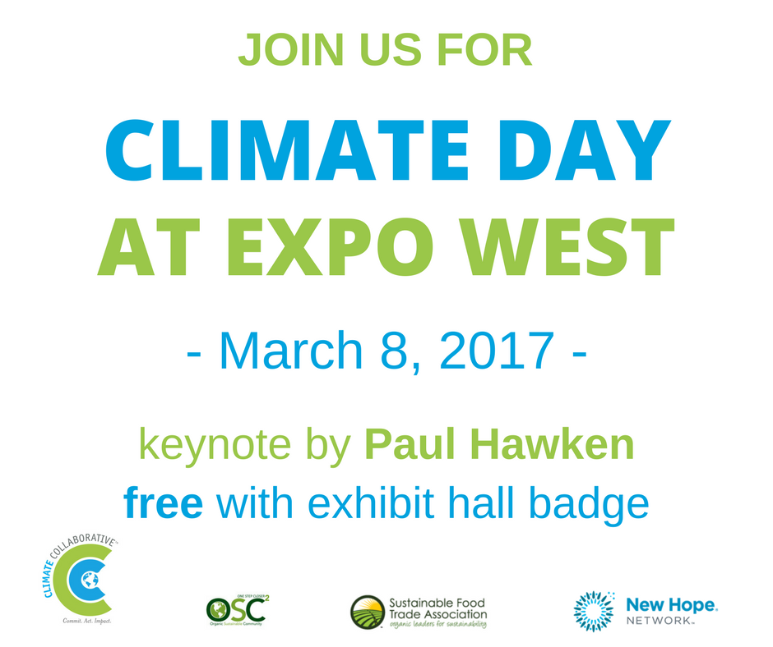
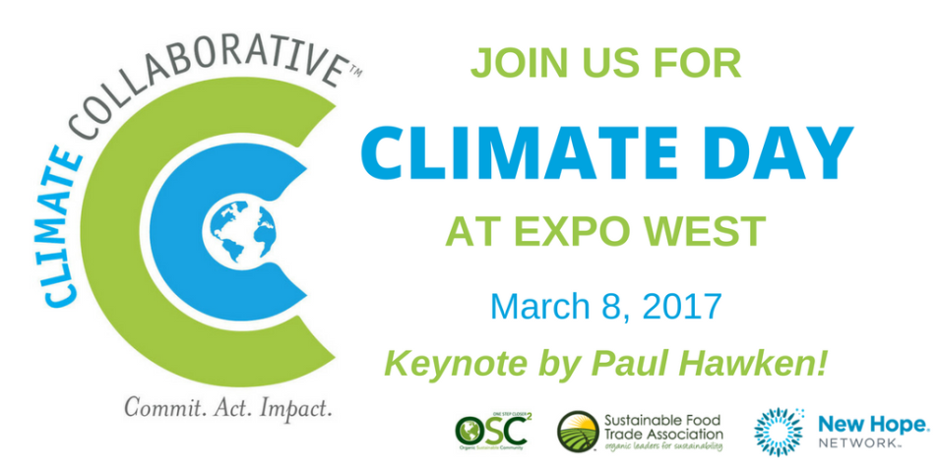

QUOTES
“The natural products industry has a proud history of leading the way on animal welfare, organic agriculture, fair trade and non-GMOs. Now it’s time to lead on climate.” – John Foraker, President, Annie’s
“Climate change is one of the biggest risks facing our businesses, and the wider world in which we operate. We know that businesses, including NCG, can and must do more. The Climate Collaborative is the unifying force that will engage and inspire the natural products industry to lead the way on behalf of consumers. We invite and encourage others to join us in this effort.” - Robynn Shrader, CEO, National Co+op Grocers
“ Our leadership in organics and non-GMO’s have always been directly linked to protecting and preserving the health of the earth and while many are following our lead in this area, we also know there is still much to be done. NOW is the time as an industry to work strategically on climate change and the impact we can have collectively. INFRA is proud to be a leader with the Climate Collaborative. " - Corinne Shindelar, CEO, Independent Natural Food Retailers Association
"As an industry but even more, as responsible citizens, we simply can't afford to ignore climate change any longer." - Gary Hirshberg, Chairman, Stonyfield
“No industry has a bigger impact on climate change than agriculture and food, both as a source of the problem and as a solution.” –Paul Hawken
“Now more than ever, our industry leaders and change makers need to collaborate to address the climate issues, it’s our planet and our future We are at the center of this movement” - Ahmed Rahim, CEO & Co-Founder, Numi Organic Tea
"As a pioneer in fair trade practices and organic and non-GMO products, we feel a great sense of responsibility to set an example for creating the change we want to see in the world. That’s why we’re rising to the challenge to lead the way in climate change. We’ve already shifted the way carbon emissions are offset, introducing in-setting by means of large-scale reforestation programs in the cooperatives that produce our crops. We’ve also introduced compostable packaging. We want to continue to shift the way others work and think so we can help create a sustainable future for our planet and people.”
- Mathieu Senard, co-founder and co-CEO of Alter Eco

