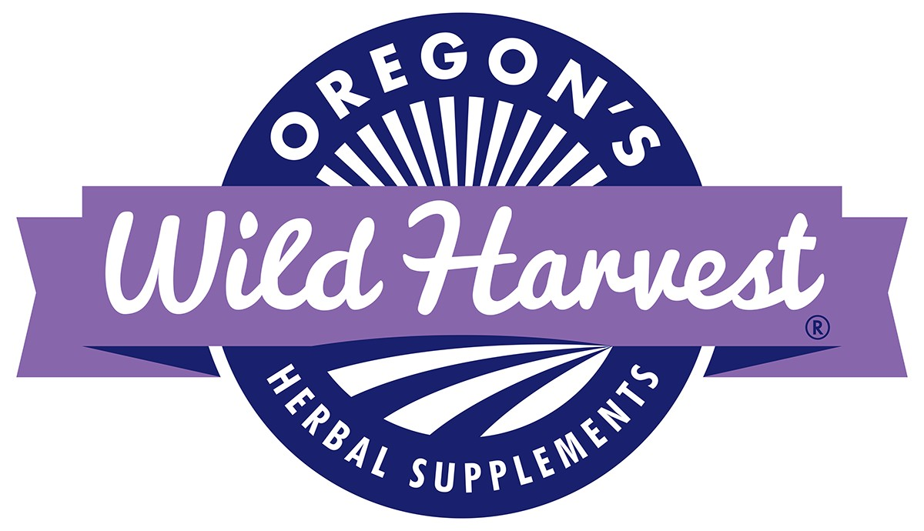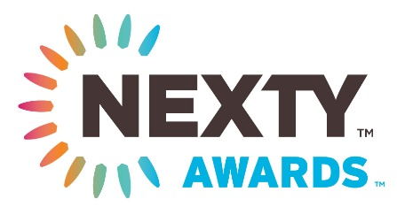

Oregon’s Wild Harvest Wins a 2017 NEXTY Award

Organic Herbal Supplement Company is one of only 27 winners of the coveted NEXTY Awards announced at Natural Products Expo West

Redmond, OR - March 21, 2017 – Oregon’s Wild Harvest is one of only 27 winners of the New Hope Network 2017 Expo West NEXTY Awards for outstanding new products in the natural products industry. Oregon’s Wild Harvest’s line of Demeter™ Certified Biodynamic™ herbal tonics won for Best Herbal Supplement.

NEXTY Awards are given to products that display the utmost in innovation, integrity and inspiration, helping forward the work of the natural products industry to deliver more healthful, trusted and sustainable products to consumers.

Oregon’s Wild Harvest was one of 72 finalists selected from more than 720 entries across 27 categories, such as Best New Mission-Based Product or Best New Organic Product, by a national panel of natural products industry experts. Winners were announced and presented with their awards on March 11, 2017 at Natural Products Expo West in Anaheim, CA.

“We are humbled and honored to have our line of Biodynamic herbal tonics recognized as the Best New Supplement for 2017,” says Randy Buresh, R.N., farmer and chief visionary officer at Oregon’s Wild Harvest. “Many years ago, we became biodynamic farmers because it fit with what we believed in – respecting the diversity of Mother Earth, the soil, plants, animals, bees and humans - and a lifestyle we thoroughly embraced.”

Buresh explained that Biodynamic farming understands that everything is interrelated and connected in life. The inspiration for making a product that nurtured the health of the earth and created homeostasis in people was a perfect fit for our company and a powerful answer to maintaining balance in today’s stressful world. Our line of Demeter Certified Biodynamic herbal tonics is grown with love, manufactured with the highest quality standards, validated with scientific research and designed with the future in mind. We care for these tonics from seed to the bottle and work to create a product that’s made with powerful plants to support the strength in people, with a taste that’s out of this world.

“These 27 products represent the future of the natural products industry where sustainability and transparency are the norm,” says Jessie Shafer, content director at New Hope Network and one of the NEXTY judges. “Our industry can have a huge influence on how big manufacturers and mainstream buyers think about consumer packaged goods. The winners of our NEXTY awards inspire change and integrity in everything from ingredients to packaging.”

NEXTY Awards are a twice-annual award connected to New Hope Network's Natural Products Expo shows in March and September. They were created to recognize the most game-changing and inspiring products in the natural/organic CPG market today. Products are nominated and winners are chosen through a two-tier judging process by the New Hope Network content team and a panel of industry judges. Learn more about the NEXTY awards at expowest.com/nexty .

For more information on Oregon’s Wild Harvest, visit www.oregonswildharvest.com

PR Contact: Amy Brown amy@owharvest.com 503.341.3795

